Capstone Pre-Production Document

Description:

I will be building a “lost in the forest” simulation, where the user will move through the woods with very little light, and the dynamic, frightening noises will play all around. The goal of this app is to make users feel afraid.

The experience will begin with a slow fade-in from black, to a foggy, creepy forest at midnight. Crickets can be heard in the back ground. There will be a button in the middle of the screen that says “Find Shelter”, and when the user clicks it, an on-rails style of movement will begin through the woods. In the end, the user will enter a dark cave and the scene will fade to black, and then footsteps will be heard approaching.

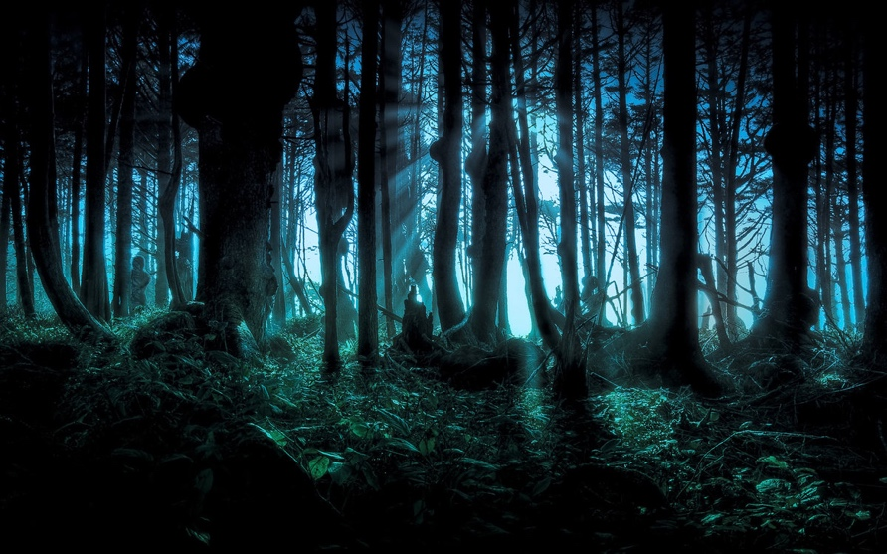

There will be different visual features that will appear during the trip, such as glowing eyes, obscure creatures dashing across the screen, flying birds, old traps, ropes, etc.

Features and Dependencies

1. 3D Models & Animations
   1. Terrain

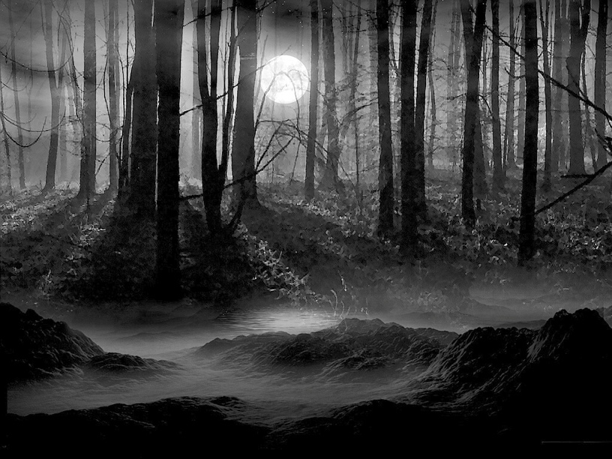

* 1. Trees

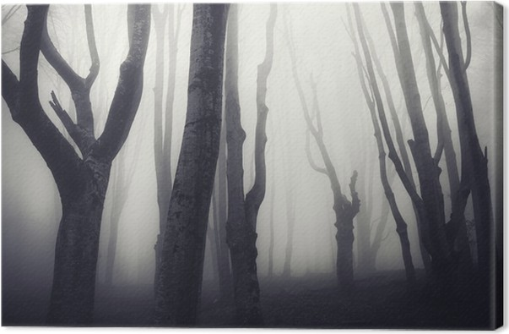 

* 1. Wolf



* 1. Birds



* 1. Cave

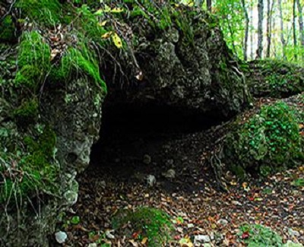

1. Game Loop
   1. Player movement over uneven terrain
   2. Animals rush in front or behind user
   3. Eyes / faces / ghosts appear around the user
   4. Dynamic spatial audio that will surround the player
   5. Ending with fade to black, and footsteps can be heard approaching
2. Other Effects
   1. Flickering flashlight
   2. Fog
   3. Particle effects for dust in the air
   4. Moonlight with light beams
   5. Navigation mesh for user movement

Feature and Dependencies

1. 3D Models and Animations
   1. Trees and wind effects

Revised: Will use free assets from the Unity Asset Store

* 1. Wolf and running animation

Revised: Will not use a wolf model in this application, only wolf sounds

* 1. Ghost

Revised: Will use a model from the Unity Asset Store

* 1. Cave
  2. Rock
  3. Terrain

1. Game Loop
   1. Player movement over uneven terrain

* Used NavMesh
  1. Animals rush in front or behind user
* **Revised: Will use 1 ghost and other creepy noises. I will not use any animals**
  1. Eyes / faces / ghosts appear around the user
* **Revised: No eyes or faces, just a ghost and some noises**
  1. Dynamic spatial audio that will surround the player
* Using unity resonance audio, works great
  1. Ending with fade to black, and footsteps can be heard approaching
* Footsteps and heavy breathing can be heard approaching
  1. **Added: User can make a decision which path to take**
  2. **Added: Falling rock off mountain when the user picks a path**

1. Other Effects
   1. Flickering flashlight

* Revised: I didn’t want to make a flickering flashlight because I did not want to allow realtime lighting on the terrain
  1. Fog
  2. Particle effects for dust in the air
* **Lighting fog and volumetric fog**
  1. Moonlight with light beams
* **Revised: I didn’t any moonlight beams**
  1. Navigation mesh for user movement